Ujian Akhir Praktikum - Semester Genap 2019/2020
Practicum Final Exam - Even Semester Year 2019/2020
Matakuliah  Subject |  |  | COMP6580 – Database Administration |  |  | 
Kelas  Class | : | BA01 / BB01 / BC01 / BD01 / BE01 / BF01 / BG01 / BH01 / BI01 / BJ01 / BK01 / BL01 / BM01 / BN01 |  | Tanggal Mulai  Start Date | : 11 June 2020
Kelas  Class | : |  |  | Waktu Mulai  Start Time | : 11.20
Dosen  Lecturer | : | D2098 - Dr. Agus Widodo, B.Sc., M.T.  D0214 - Drs. Yusrizal Oenzil, M.Sc.  D6198 - Fepri Putra Panghurian, S.Kom., M.T.I. |  | Tanggal Selesai  End Date | : 12 June 2020
Dosen  Lecturer | : |  |  | Waktu Selesai  End Time | : 11.20

PERATURAN UJIAN:
Exam Regulations:
- Mahasiswa tidak diperbolehkan berdiskusi dan/atau bekerja sama dengan peserta ujian lainnya
Student is not allowed to discuss and/or work together with other exam participants
- Mahasiswa tidak diperbolehkan menyalin jawaban dari intenet
Student is not allowed to copy answer from the intenet
- Asisten BERHAK memberi nilai 0 (NOL) bagi peserta ujian yang melakukan segala bentuk kecurangan
Assistant is able to give 0 (ZERO) score for exam participant who does any cheating actions
- Kumpulkan jawaban tepat pada waktunya di https://laboratory.binus.ac.id/lab
Submit the answer on time at https://laboratory.binus.ac.id/lab
- Bila Anda tidak membaca peraturan ini, maka Anda dianggap telah membaca dan menyetujuinya
If you have missed to read these regulations, so you are considered to have read and agreed on it

SOFTWARE YANG DIGUNAKAN:
Software will be used:
- SQL Server Management Studio 2016

FILE YANG DIKUMPULKAN:
File must be collected:
- *.sql

PERHATIAN!
Attention!
- Bagi yang mengerjakan tidak sesuai dengan soal, maka akan diberikan nilai NOL (0)
For those who do not work in accordance with the exam case will be marked as ZERO (0)
- Bagi yang mengerjakan tidak sesuai dengan software dan versi yang telah ditetapkan, maka akan tetap dikoreksi dengan software dan versi yang telah ditetapkan
For those who do not work in accordance with the software and specific version will be corrected by the predefined software and version
- Kompres semua jawaban yang akan diunggah. Pastikan format pengumpulan nama file dan ekstensi sesuai dengan format berikut: [NIM]-[NAMA].zip
Compress all file that will be uploaded. Make sure the format for collecting file name and extension according to the following format: [NIM]-[NAME].zip

Soal
Case

Sociolla
Sociolla is a store in Indonesia that sells beauty products including skin care, make-up, etc. As time goes by, the owner needs detailed information about their products to estimate their income. The owner is planning to build DBMS to support their business activity. As a Database Administrator, you are asked to make these following tasks:
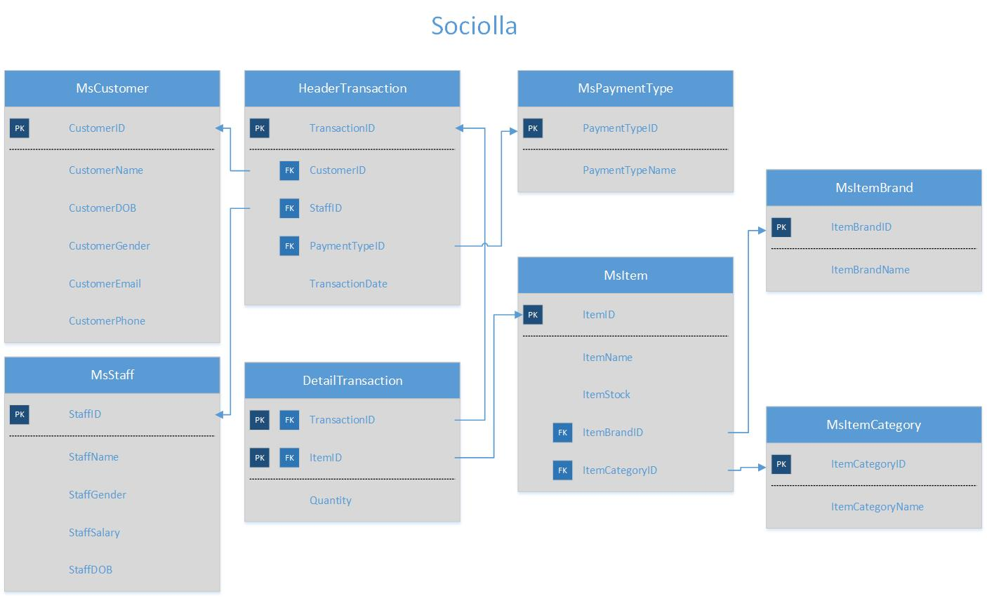

Execute the provided create and insert query file on “Sociolla” database! (“create+insert.sql”)
- Create a new job with the following detail:
Job Name | Quarterly Report
Owner | System Administrator
Category | Data Collector
Description | Generate quarterly report of all transactions that occur
Schedule | Occurs every last day of every 3 month(s) at 23:00:00.
Step | - Display TransactionID, CustomerName, StaffName, TransactionDate, Total Item (obtained from the sum of item bought), Total Quantity (obtained from the sum of quantity), and Total Purchases (obtained from the multiplication between quantity and price) for every transaction in the current quarter. (adjust to your day executing the command)  - Save the output in a file named “ReportDetails.txt”

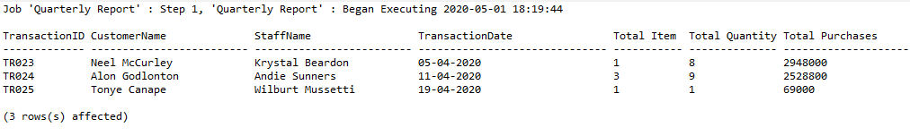
Figure 1. Executed on 1 May 2020

- Create a new job with the following detail:
Job Name | Remaining Stock Report
Owner | System Administrator
Category | Data Collector
Description | Generate a report to print out the remaining stock of every item
Schedule | Occurs every last weekend of every 2 month(s) at 22:30:00.
Step | - Display ItemID, ItemName, and Remaining (obtained from the subtraction between ItemStock and the total quantity).  - Save the output in a file named “RemainingStock.txt”

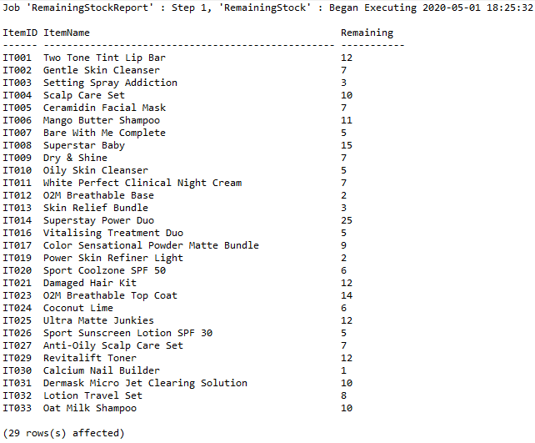

- Create a stored procedure named “ValidateItem” that retrieves ItemID, ItemName, ItemStock, ItemPrice, ItemBrand and ItemCategory as a parameter. There are several validations that must be made:
- If the inserted item already exists in the MsItem table, print ‘Item already exist’
- If inserting an item with an existing Item Name and different Item ID, print ‘This item already exists with different ID’
- If inserting an item with an existing Item ID, print ‘ID must be unique’
- If inserting an item with a non-existing Item ID and Item Name, insert the item.
Display after executing an Item with an existing Item ID and Item Name:
EXEC ValidateItem ‘IT034’, ‘Ki Gold Set’, 23, 100000, ‘IB001’, ‘IC001’

Display after executing an Item with an existing Item Name and different Item ID:
EXEC ValidateItem 'IT035', 'Ki Gold Set', 23, 100000, 'IB001', 'IC001'

Display after executing an Item with an existing Item ID:
EXEC ValidateItem 'IT034', 'Mediheal Set', 23, 100000, 'IB001', 'IC001'

Display after executing an Item with a non-existing Item ID and Item Name:
EXEC ValidateItem 'IT035', 'Mediheal Set', 23, 100000, 'IB001', 'IC001'

Display after passing all validations:
SELECT * FROM MsItem WHERE ItemID = 'IT035'
- Create a stored procedure named RemoveItem that retrieves ItemID as a parameter. Validate if the item doesn’t exist, print ‘Item doesn’t exist’. Then check if the item is in the Top 5 Most Selling Item (obtained by taking 5 data from the sum of Quantity), print ‘Item cannot be deleted because it is in the Top 5’. If the item isn’t in the Top 5 Most Selling Item, it will update the Item Stock to 0 instead.
Display after executing an Item ID that doesn’t exist:
EXEC RemoveItem 'IT035'

Display after executing an Item ID which is in the Top 5:
EXEC RemoveItem 'IT001'

Display after executing an Item ID which exist and is not in the Top 5:
EXEC RemoveItem 'IT023'
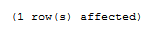

Display after passing all validations:
SELECT * FROM MsItem WHERE ItemID = 'IT023'

- Create a stored procedure named DeleteItem that retrieves an Item ID as a parameter. Validate if the item doesn’t exist, print ‘Item doesn’t exist’. Then check if the item has never been bought, delete the item. If the item has been bought before, then print ‘Item cannot be removed’.
Display after executing an Item ID that doesn’t exist:
EXEC DeleteItem 'IT035'

Display after executing an Item ID that has been bought before:
EXEC DeleteItem 'IT001'

Display after executing an Item ID that has never been bought:
EXEC DeleteItem 'IT034'

Display after passing all validations:
SELECT * FROM MsItem WHERE ItemID = 'IT034'

- Create a trigger named InsertItemTrigger on the MsItem table that will be triggered when an Insert action occurred on the MsItem table. This trigger will check whether the inserted data meets the required constraint. Print out messages on the Messages tab on every error that occurred.
- If the inserted Item ID already exists, print ‘Item ID already exists’
- If the inserted Item ID isn’t in the right format, print ‘Item ID must be in the right format’
- If the inserted Item Stock is less than 10, print ‘Item Stock must be greater than 10’
- If the inserted Item Brand isn’t in the right format, print ‘Item Brand must be in the right format’
- If the inserted Item Brand doesn’t exist, print ‘[Inserted Item Brand] doesn’t exist’.
Ex: ‘IB016 doesn’t exist’
- If the inserted Item Category isn’t in the right format, print ‘Item Category must be in the right format’
- If the inserted Item Category doesn’t exist, print ‘[Inserted Item Category] doesn’t exist’.
Ex: ‘IC006 doesn’t exist’
- Insert the item to MsItem table after passing all validations

Display after passing all validations:
SELECT * FROM MsItem WHERE ItemID = 'IT035'

- Create a trigger named RefundTransaction on the HeaderTransaction table that will be triggered when an update action occurred on the HeaderTransaction table. An update on HeaderTransaction will only occur if there’s a refund transaction. Therefore, there are some changes that need to be made:
- Change the Payment Type into Refund for the involved transaction
- Change the Transaction Date into the day of refund (adjust to your day of executing the command)
- Add the refunded quantity into the Item Stock

After making all changes, display the previous Payment Type¸ Transaction Date, and Stock followed by the updated Payment Type¸ Transaction Date, and Stock

Display after the trigger is executed:
UPDATE HeaderTransaction
SET PaymentTypeID = 'PT007'
WHERE CustomerID = 'CS001'
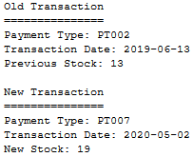
Figure 2. Executed on 2 May 2020

- Create a stored procedure named PrintReceipt that retrieves Transaction ID as a parameter and combined with a cursor to display the detail of the inserted Transaction ID. Validate if the inserted Transaction ID doesn’t exist, print ‘Transaction ID doesn’t exist’.
- Each time the stored procedure is executed, it will display the Transaction Date, Cashier Name, and Payment Type according to the Transaction ID inputted by user.
- It will also display the details of the Item, including Item Name, Quantity, Item Brand, Item Category, Price per item (obtained from Item Price), and Total (obtained from multiplication of each Item Price and Quantity). At the end, show Total Item (obtained from count of all displayed Item) and Total Price (obtained from the sum of Total)
Display after the stored procedure is executed:

EXEC PrintReceipt 'TR025'
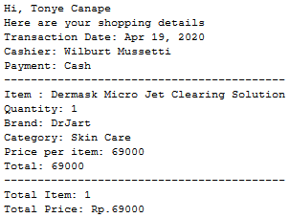

- Create a stored procedure named SearchItem that retrieves Brand as a keyword in the parameter combined with a cursor to display items from the inserted Brand.
- If the inserted keyword is less than 3 characters, print ‘Keyword must be longer than 3 characters’
- If the inputted Brand doesn’t exist, print ‘Brand doesn’t exist’
- If the inputted Brand exist, display the details of each Item from the inserted Brand, including Item ID, Item Name, Item Stock, and Item Price.
Display after the stored procedure is executed:

EXEC SearchItem 'taph'
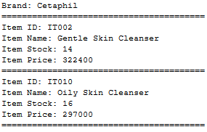

- Create a stored procedure named DisplayTransaction that retrieves starting month (in integer), ending month (in integer), and year of transaction as a parameter combined with a cursor to display the details of all the transactions between the starting month and ending month in the inserted year.
- Validate if the range of inputted starting month and ending month is more than 10 months, print ‘The maximum range is 10 months’
- If the inputted range is within 10 months, it will display the Starting Month inputted by user in datename format and the Ending Month inputted by user in datename format.
- It will also display the Transaction ID and Transaction Date of every transactions that occur within the range inputted by user.
- Following the Transaction ID and Transaction Date, it will also display the details of each transactions, including Item Name, Item Price, Quantity, and Total (obtained from multiplication of shown Item Price and Quantity)
- At the end, show Total Price (obtained from the sum of Total)
Display after the stored procedure is executed:

EXEC DisplayTransaction 10, 11, 2019
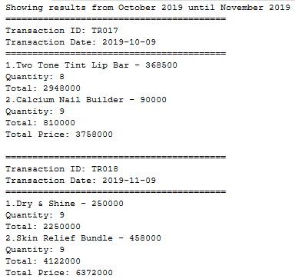
CAUTIONS!
Files need to be collected:
- *.sql
Contains answers for number 1 - 10. Answer must be in SQL script for creating a job, stored procedure, stored procedure + cursor, and trigger.

Good Luck 😊
Any questions regarding this exam, please ask your Assistant!

